
Routing Management

Wire and Cable Tie Straps

Description

Today’s automobiles incorporate a huge collection of wires, hoses and tubing that must be efficiently routed through the vehicle. Secure attachments must be made in a variety of locations and under a wide range of operating environments.
Emhart Teknologies offers a broad range of engineering routing and fastening solutions.

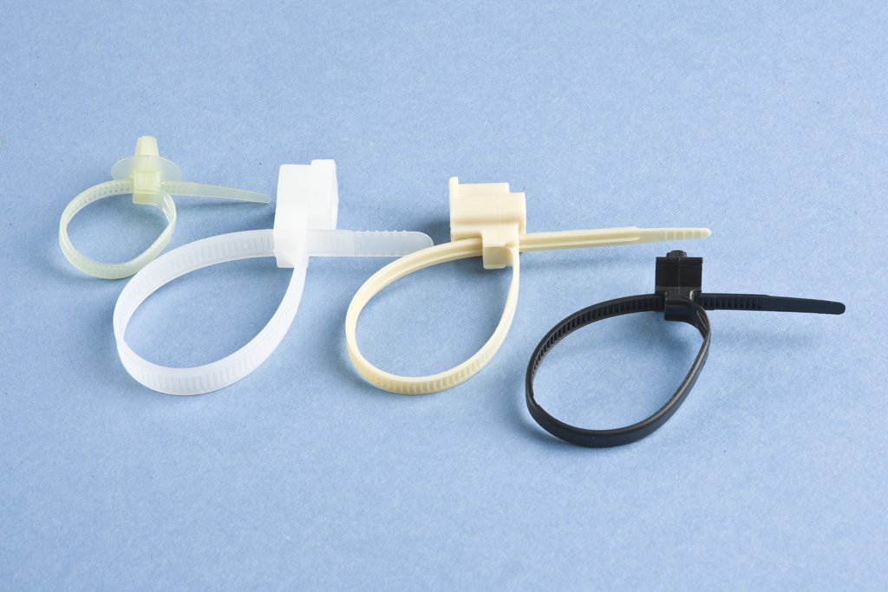

Design Considerations

Successful tie strap design must account for a logical series of eventualities:
- Capturing – Must deal effectively with the process of grouping wires into bundles.
- Positive Positioning – Must maintain the relative location of the fastener on the harness.
- Vehicle Attachment – Must ensure secure and ergonomically-friendly attachment.
- Durability – Must perform exceptionally under a wide range of operating and environmental conditions over the life of the vehicle.
- Serviceability – Must allow accessibility for servicing or replacement of underlying components.

Features/Benefits

- Ensure positive closure and clamping retention with integral ratchet feature
- Manages large variations in bundle sizes, making it possible to commonize straps across multiple applications
- Serviceable by incorporating a quick-releasing flex finger into the ratchet
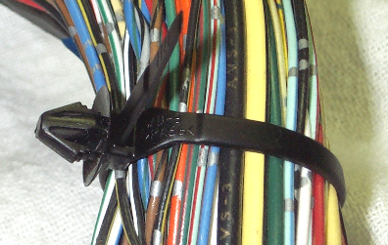

Emhart’s Full Service Capabilities

Dedicated Program Management
Product Design/Development
- Application & System Engineering
- Computer Aided Designs/Methods
- Prototype & Tooling Design
- Testing & Design Validation
Launch/Production Support
- Process Development
- Quality Planning
- Change Management
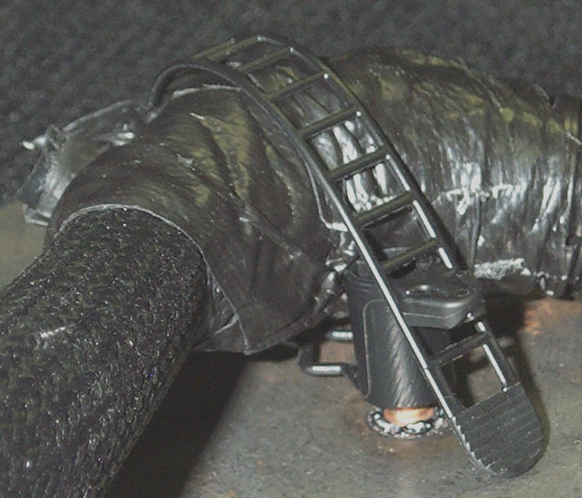
For more product information, please contact Emhart Teknologies at (586) 949-0440 Ext. 339.
Release C Effective 04/25/2011

