Variance Management

Mini-Cage Assembly

Description

Emhart Teknologies’ Mini-Cage assembly allows for variation management of a multitude of applications. The two piece design allows for welding of the fastener into the desired location and allowing movement in all axes. Coating is applied to the nut portion to reduce secondary coating operations from adhering. This coating is also a torque tension modifier.

Applications

Variation Management
- Fuel tank hold downs
- Interior cargo fastener
- Small footprint locations
- Seat attachments

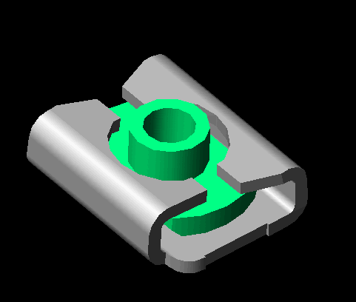

Emhart’s Full Service Capabilities

Product Design/Development
- Application/Systems Engineering
- Computer Aided Designs/Methods
- Prototype & Tooling Design
- Testing & Design Validation
Launch/Production Support
- Process Development/Quality Planning
- Change Management

Features/Benefits

- True Class 10 product
- Small footprint
- Provides up to 2.5 mm of float
- Sizes from M8 thru M14
- TorkMagik™

  - Achieve clampload with less torque
  - Narrows torque distribution to achieve clampload
  - Less costly than Teflon®
  - Protects from e-coat build-up in threads
  - Minimizes fastener sticking after e-coat
  - Available in multiple colors- ‘Poke-Yoke’ as a manufacturing process

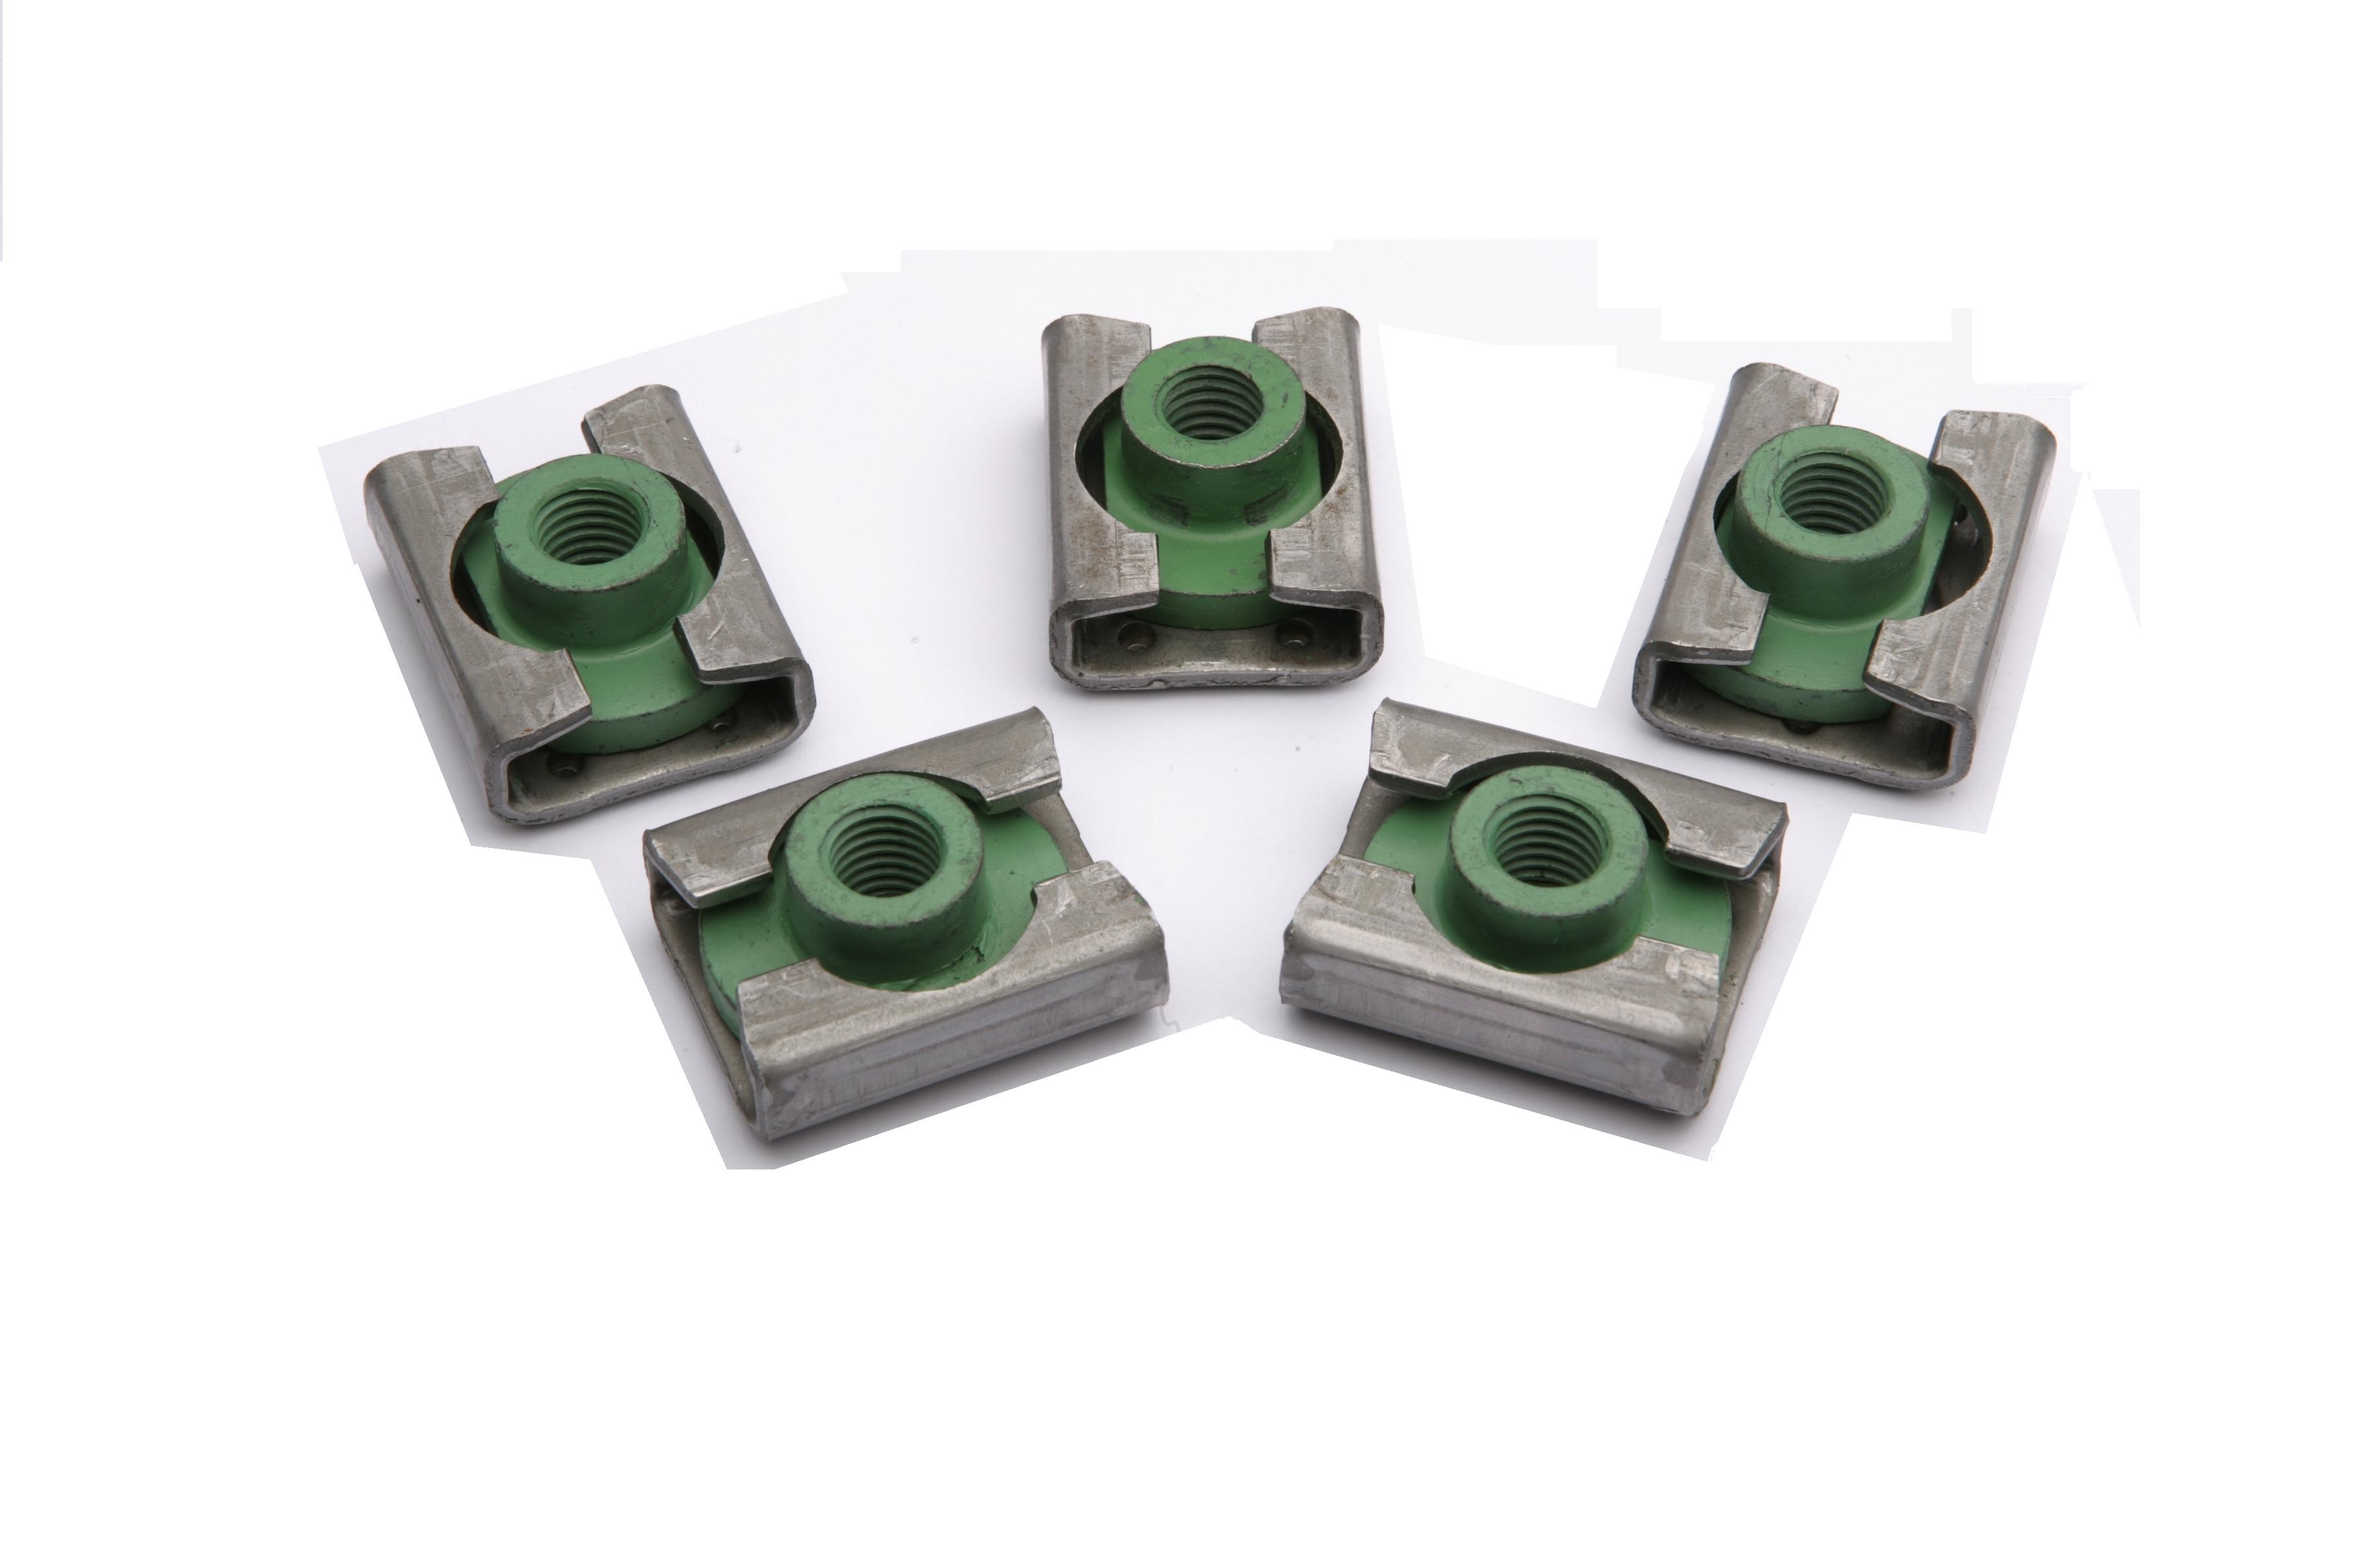



Our staff has been trained to apply Lean and 6-Sigma methods so we can help you identify solutions as they relate to your process as well as your part design.

For more product information, please contact Emhart Teknologies at (586) 949-0440 Ext. 232.

