Variance Management

Cage Assembly

Description

Emhart Teknologies’ Cage assembly allows for variation management of a multitude of applications. The design allows for welding of the fastener into the desired location and allowing movement in all axes. “Lift Tabs” are present to reduce secondary coating operations from adhering. Two versions are available one being open on the top and allowing for replacement of the fastener. The other being encapsulated after being welded (Inverted) allowing for the re-use of the fastener after disassembly.

Applications

Variation Management
- Body to frame
- Suspension
- Body components
- Engine Cradle

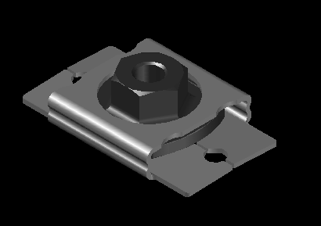

Emhart’s Full Service Capabilities

Product Design/Development
- Application/Systems Engineering
- Computer Aided Designs/Methods
- Prototype & Tooling Design
- Testing & Design Validation
Launch/Production Support
- Process Development/Quality Planning
- Change Management

Features/Benefits

- Available in Class 9 and Class 10
- Footprint designed to meet application
- Provides up to 4.5 mm of float
- Sizes from M8 thru M16
- Prevailing Torque feature is available.

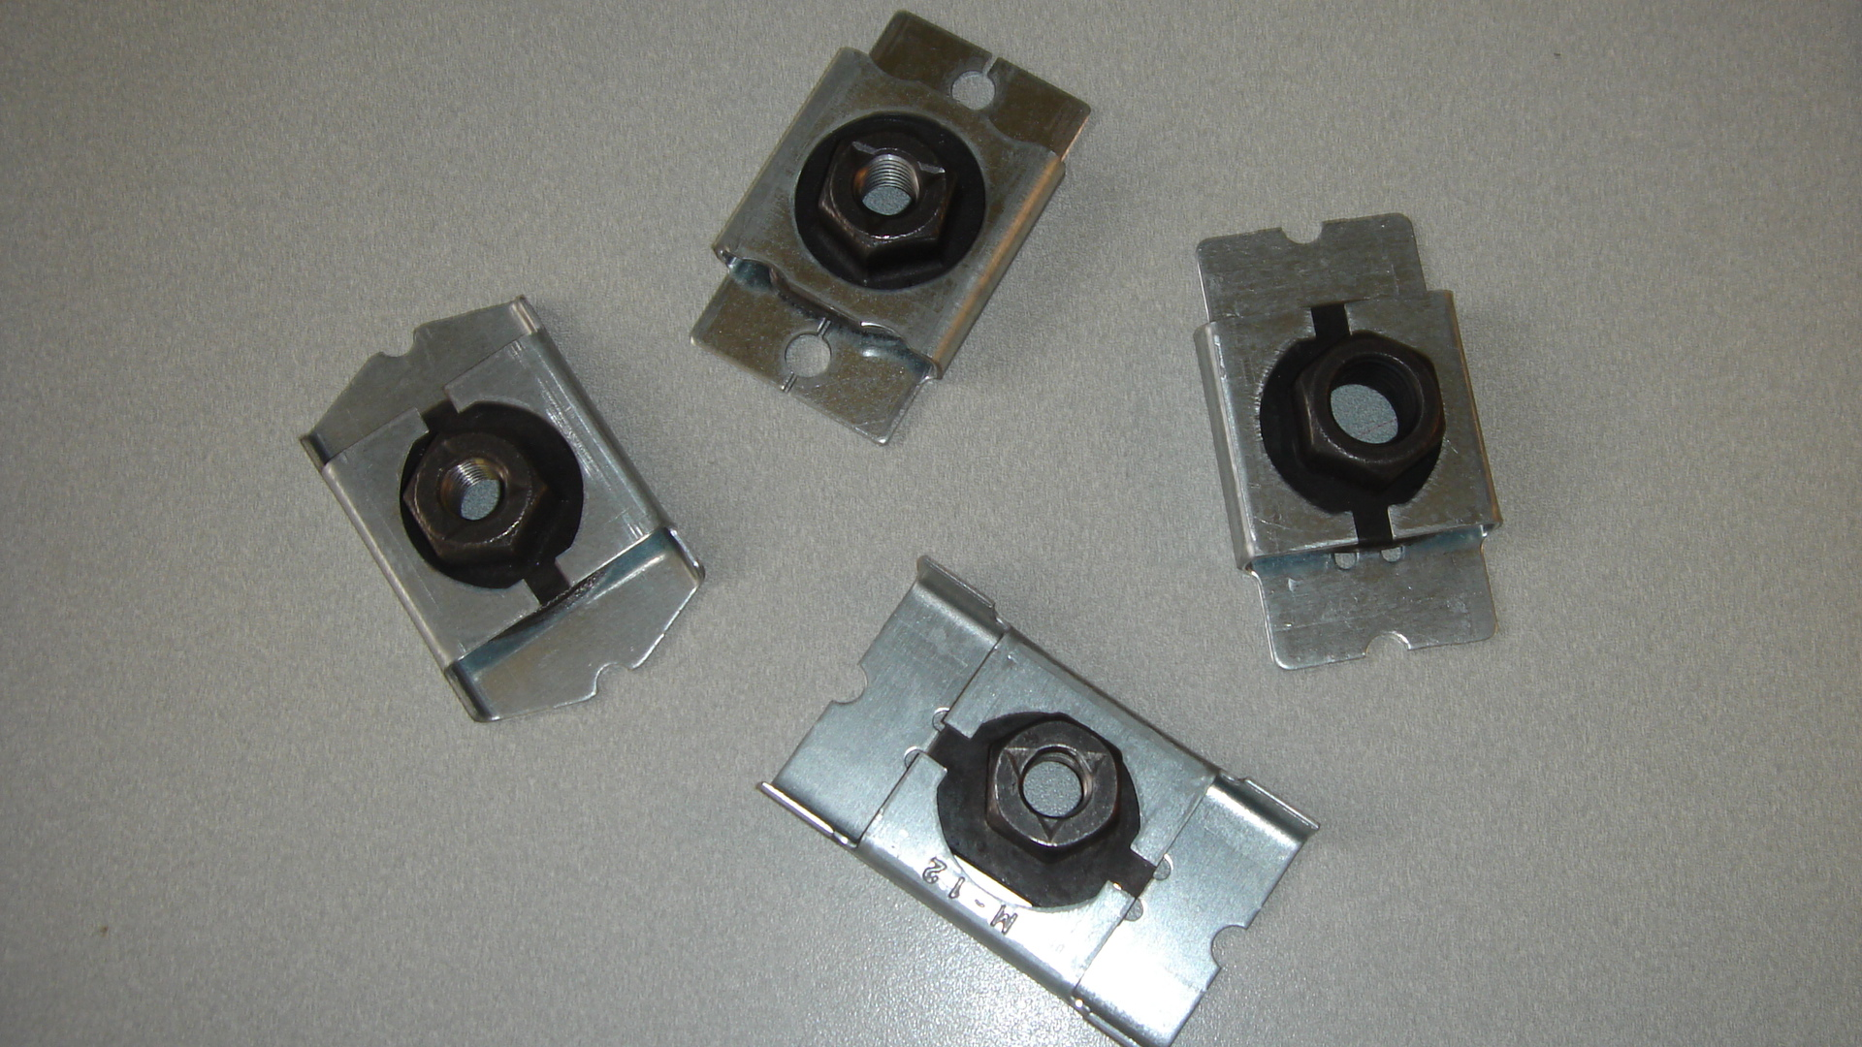



Our staff has been trained to apply Lean and 6-Sigma methods so we can help you identify solutions as they relate to your process as well as your part design.

For more product information, please contact Emhart Teknologies at (586) 949-0440 Ext. 232.

